1. Enter the first matrix and then display it. Secondly, enter the second matrix and then display it. In the result by apply 2D arrays show Addition, subtraction of 2 matrix's.

**SOLUTION:**

int a, b, i, j, m, n, x, y;

Console.Write("enter no of rows: ");

int row = int.Parse(Console.ReadLine());

Console.Write("enter no of cols: ");

int col = int.Parse(Console.ReadLine());

int[,] matrix = new int[row, col];

for ( i = 0; i < row; i++)

{

for ( j = 0; j < col; j++)

{

Console.Write("matrix[{0},{1}]= ",i,j);

matrix[i, j] = int.Parse(Console.ReadLine());

}

}

Console.WriteLine();

for ( i = 0; i < row; i++)

{

for ( j = 0; j < col; j++)

{

Console.Write(" "+matrix[i,j]);

}

Console.WriteLine();

}

Console.Write("\n\nenter no of rows for matrix 2: ");

int row1 = int.Parse(Console.ReadLine());

Console.Write("enter no of cols for matrix 2: ");

int col1 = int.Parse(Console.ReadLine());

int[,] matrix1 = new int[row, col];

for ( a = 0; a < row1; a++)

{

for ( b = 0; b < col1; b++)

{

Console.Write("matrix1[{0},{1}]= ",a,b);

matrix1[a, b] = int.Parse(Console.ReadLine());

}

}

Console.WriteLine();

for ( i = 0; i < row1; i++)

{

for (j = 0; j < col1; j++)

{

Console.Write(" "+matrix1[i,j]);

}

Console.WriteLine();

}

m = matrix.GetLength(0);

n = matrix.GetLength(1);

Console.WriteLine(" \t SUM OF MATRIX ");

int[,] sum = new int[m, n];

for ( x = 0; x < m; x++)

{

for ( y = 0; y < n; y++)

{

sum[x, y] = matrix[x,y] + matrix1[x,y];

Console.Write(" "+sum[x,y]);

}

Console.WriteLine();

}

Console.WriteLine(" \n\t SUBTRACT OF MATRIX ");

int[,] sub = new int[m, n];

for (x = 0; x < m; x++)

{

for (y = 0; y < n; y++)

{

sub[x, y] = matrix[x, y] - matrix1[x, y];

Console.Write(" " + sub[x, y]);

}

Console.WriteLine();

}

**OUTPUT:** 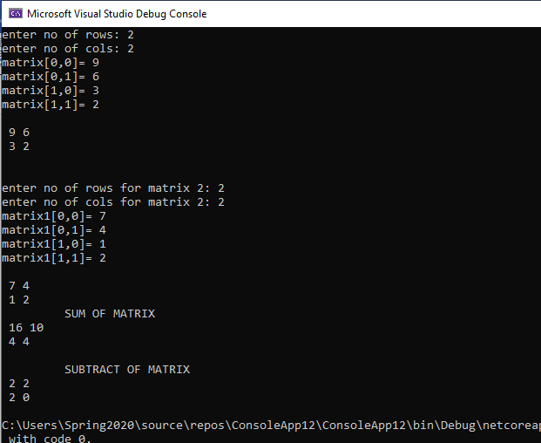

1. Take N number of user data input and make sure N is greater than 10, which contain name of the user, his/her nationality and his/her eye color. You have to show the max color of eye in each country.

**SOLUTION:**

Console.WriteLine("!!! INSTRUCTION: MUST READ\nSelect pakistan or american in nationality\nchoose colour from black,brown and green or other....!!!\n");

Console.Write("enter no of person: ");

int n = int.Parse(Console.ReadLine());

string[,] arr = new string[n,4];

int black = 0, brown = 0, green = 0,other=0;

int i_black = 0,i_brown = 0, i_green = 0, i_other = 0;

for (int i = 0; i < n; i++)

{

arr[i, 0] =Convert.ToString(i+1);

Console.Write("enter your name: ");

arr[i, 1] = Console.ReadLine();

Console.Write("enter your nationality: ");

arr[i, 2] = Console.ReadLine();

Console.Write("enter your eye colour: ");

arr[i, 3] = Console.ReadLine();

}

for (int i = 0; i < n; i++)

{

if (arr[i,2]=="pakistan")

{

if (arr[i,3]=="black")

{

black++;

}

else if (arr[i, 3] == "brown")

{

brown++;

}

else if (arr[i, 3] == "green")

{

green++;

}

else if (arr[i, 3] != "black"&& arr[i, 3] != "blue" && arr[i, 3] != "green" )

{

other++;

}

}

else if (arr[i, 2] == "american")

{

if (arr[i, 3] == "black")

{

i_black++;

}

else if (arr[i, 3] == "brown")

{

i_brown++;

}

else if (arr[i,3] == "green")

{

i_green++;

}

else if (arr[i,3] != "i_black" && arr[i,3] != "i_blue" && arr[i,3] != "i_green")

{

i_other++;

}

}

}Console.Clear();

Console.WriteLine("Sr no \t\t NAME \t\t NATIONALITY \t\t EYE COLOUR\n");

for (int i = 0; i < n; i++)

{

for (int j = 0; j < 4; j++)

{

Console.Write(arr[i,j]+"\t\t");

}

Console.WriteLine();

}

{

if (black == i_black)

{

Console.WriteLine("both country have same eye colour");

Console.WriteLine("pakistan: {0}\n America: {1}", black, i_black);

}

else if (black>i_black)

{

Console.WriteLine("\npakistan have maximum black eye colour then america");

Console.WriteLine("pakistan: {0}\n America: {1}",black,i_black);

}

else

{

Console.WriteLine("\namerica have maximum black eye colour then pakistan");

Console.WriteLine("pakistan: {0}\n America: {1}", black, i_black);

}

}

{

if (brown == i_brown)

{

Console.WriteLine("both country have same brown eye colour");

Console.WriteLine("pakistan: {0}\n America: {1}", brown, i_brown);

}

else if (brown>i_brown)

{

Console.WriteLine("\npakistan have maximum brown eye colour then america");

Console.WriteLine("pakistan: {0}\n America: {1}",brown,i_brown);

}

else

{

Console.WriteLine("\namerica have maximum brown eye colour then pakistan");

Console.WriteLine("pakistan: {0}\n America: {1}", brown, i_brown);

}

} {

if (green ==i_green)

{

Console.WriteLine("both country have same eye colour");

Console.WriteLine("pakistan: {0}\n America: {1}", green, i_green);

}

else if (green>i_green)

{

Console.WriteLine("\npakistan have maximum green eye colour then america");

Console.WriteLine("pakistan: {0}\n America: {1}",green,i_green);

}

else

{

Console.WriteLine("\namerica have maximum green eye colour then pakistan");

Console.WriteLine("pakistan: {0}\n America: {1}", green, i_green);

}

}

**OUTPUT:**

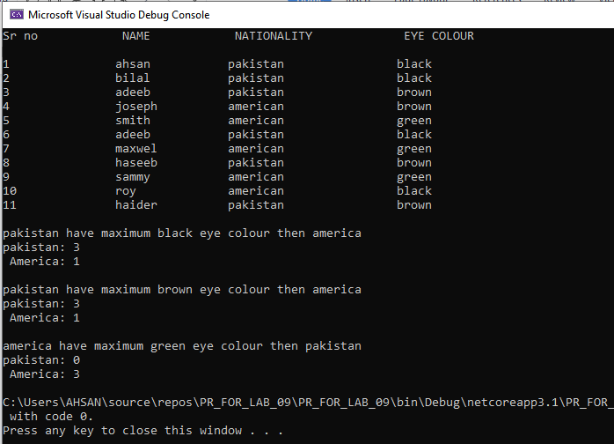

1. Make a program in C# in which take no. of items, price of items, quantity of items and name of items as input from the user and give the discount according to the following conditions (Use 2D Array):
   1. If from rice give discount of 30%.
   2. Else if the total amount is greater than 50,000 and less than 100,000 give discount of 20%.
   3. Else if the total amount is greater than 100,000 give discount of 30%.

**SOLUTION:**

int n , a , b , price , t_price = 0 ,s_price;

Console.Write("how many type of items you want to buy: ");

n = int.Parse(Console.ReadLine());

string [,] arr = new string[n, 4];

for (int i = 0; i < n; i++)

{

Console.Write("item no: ");

a = int.Parse(Console.ReadLine());

arr[i, 0] = Convert.ToString(a);

Console.Write("enter name of item: ");

arr[i, 1] = Console.ReadLine();

Console.Write("price of this item: ");

price = int.Parse(Console.ReadLine());

arr[i, 2] = Convert.ToString(price);

Console.Write("how many item you want to buy: ");

b = int.Parse(Console.ReadLine());

arr[i, 3] = Convert.ToString(b);

s_price = price * b;

t_price = t_price + s_price;

}

Console.Clear();

Console.WriteLine("\n>>>>>>>>>>>>-------- S H O P P I N G L I S T --------<<<<<<<<<<<<");

Console.WriteLine("\nitem_no \t\t name \t\t\t price \t\t quantity\n");

for (int i = 0; i < n; i++)

{

for (int j = 0; j < 4; j++)

{

Console.Write(arr[i,j]+"\t\t\t");

}

Console.WriteLine();

}

Console.WriteLine("\n\ttotal bill= "+t_price);

if (arr[0,1]=="rice"|| arr[1, 1] == "rice"||arr[2, 1] == "rice")

{

Console.WriteLine("\tdiscount = 30%");

// t_price =total price d_price = discount dt_price = discount price

double d_price = t_price * 0.3;

double dt_price = t_price - d_price;

Console.WriteLine("\tbill after discount = " + dt_price);

}

else if (t_price>=50000&&t_price<=1000000)

{

Console.WriteLine("\tdiscount = 20%");

// t_price =total price d_price = discount dt_price = discount price

double d_price = t_price * 0.2;

double dt_price = t_price - d_price;

Console.WriteLine("\tbill after discount = "+ dt_price);

}

else if (t_price>=1000000)

{

Console.WriteLine("\tdiscount = 30%");

// t_price =total price d_price = discount dt_price = discount price

double d_price = t_price * 0.3;

double dt_price = t_price - d_price;

Console.WriteLine("\tbill after discount = "+ dt_price);

}

**OUTPUT:** 